5.8 Pipes

This section will guide you to:

* Implement pipes in Angular

This guide has three subsections, namely:

5.8.1 Use built-in Angular pipes

5.8.2 Use custom Angular pipes

5.8.3 Pushing the code to Github repositories

**Step 5.8.1:** Using built-in Angular pipes

* Set product name to uppercase using in-built pipe in *Product-list.component.html*.

            <td [style.color]="'#306A9D'" [style.font-weight]="700">

                {{ p.productName | uppercase }}

            </td>

**Output:**

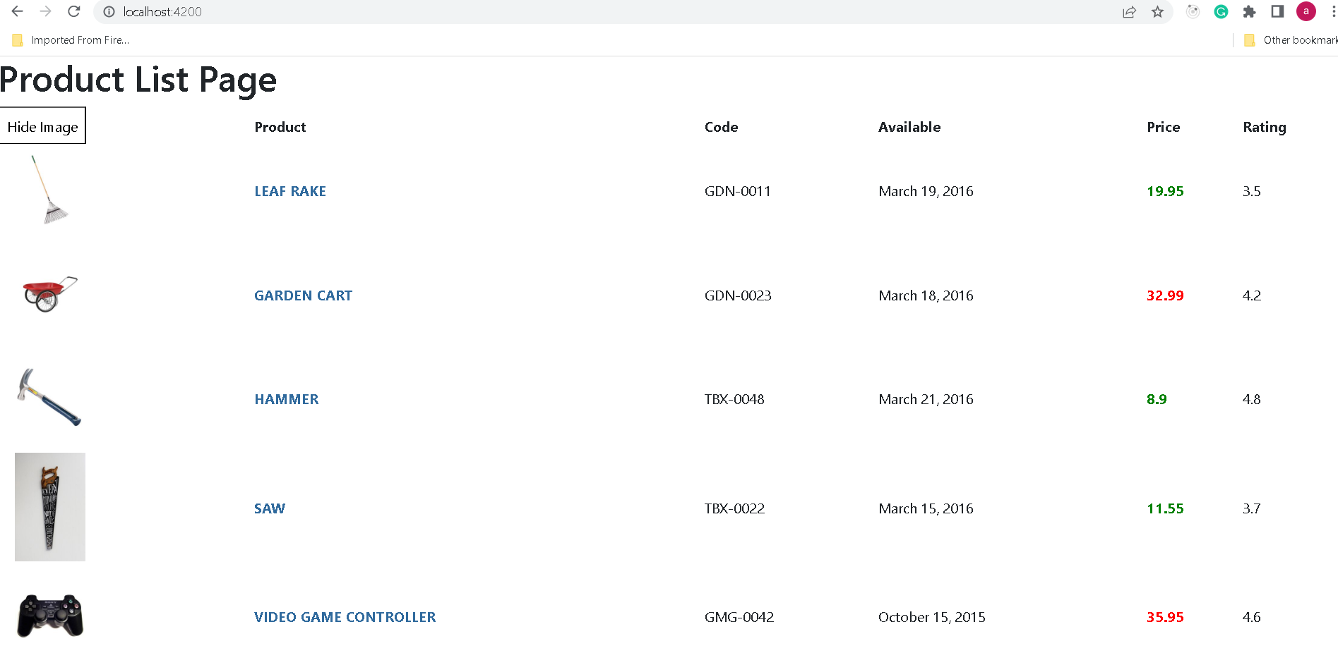

**Step 5.8.2:** Using custom Angular pipes

* Create the custom pipe using ng command **ng generate pipe convert-to-space.**

import { Pipe, PipeTransform } from '@angular/core';

@Pipe({

  name: 'convertToSpace'

})

export *class* ConvertToSpacePipe implements *PipeTransform* {

  transform(*value*: *unknown*, ...*args*: *unknown*[]): *unknown* {

    return null;

  }

}

**Do the changes in the file**

import { Pipe, PipeTransform } from '@angular/core';

@Pipe({

  name: 'convertToSpace'

})

export *class* ConvertToSpacePipe implements PipeTransform {

  transform(*value*:*string*, *character*:*string*, ) {

    return *value*.replace(*character*, '@');

}

}

* This file imported in app.module.ts file

import { NgModule } from '@angular/core';

import { BrowserModule } from '@angular/platform-browser';

import { AppRoutingModule } from './app-routing.module';

import { AppComponent } from './app.component';

import { ProductsComponents} from './products/products.component';

import { ConvertToSpacePipe } from './convert-to-space.pipe';

@NgModule({

  declarations: [

    AppComponent,

    ProductsComponents,

    ConvertToSpacePipe

  ],

  imports: [

    BrowserModule,

    AppRoutingModule

  ],

  providers: [],

  bootstrap: [AppComponent]

})

export *class* AppModule { }

* Add the following code in *Product-list.component.html*.

    <td>{{ p.code | convertToSpace:'-'}}</td>

**Output:**

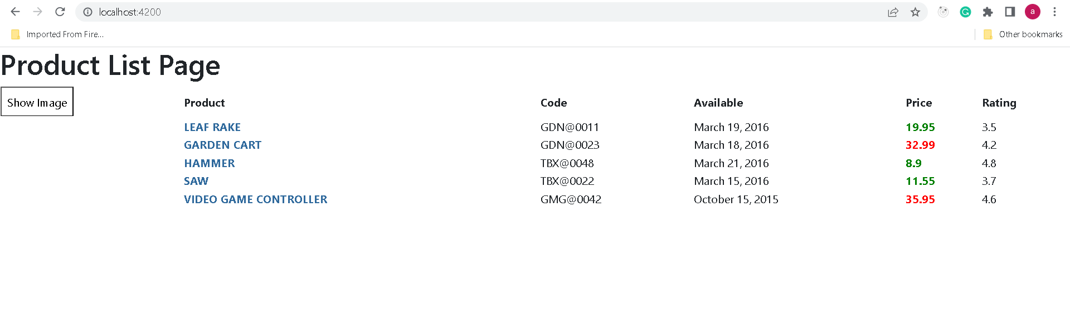

**Step 5.8.3:** Pushing the code to your GitHub repositories

Open your command prompt and navigate to the folder where you have created your files

cd <folder path>

Initialize your repository using the following command:

git init

Add all the files to your git repository using the following command:

git add .

Commit the changes using the following command:

git commit . -m “Changes have been committed.”

Push the files to the folder you initially created using the following command:

git push -u origin master